**Effects of 2019’s Social Protests on Emergency Health Services Utilization and Patients’ Severity in Santiago, Chile**

# Abstract

On October 18th, 2019, protestors gathered across Chile to call for social equality. The government responded by declaring a state of emergency and deploying the Chilean army and police, who utilized anti-riot shotguns and tear gas as a means of crowd control. This study aims to quantify the effects of the October 2019 Chilean protests on emergency health system services utilization and inpatient admission rates in three large public hospitals near to the protests focal point in Santiago.

**The next should be edited with the new methods and results**

Public data was pulled from the Chilean Ministry of Health and refined to isolate cases from age 15-64 within 3 kilometers of the protest focal point. A negative binomial model was fitted from 2015–2018 to forecast what would have happened in the absence of October’s social protests regarding trauma and respiratory cases. Predictions were compared to actual cases using t-tests and Mann-Whitney tests. Although increases in all trauma and respiratory cases were hypothesized, preliminary results varied. After October 18, trauma consultations within 1km were 19.7% lower than predicted while hospitalizations were 30.5% higher. Respiratory consultations and hospitalizations were not significantly different. Within 3km, trauma hospitalizations were 32.3% higher than predicted, respiratory consultations were 21.5% lower, and respiratory hospitalizations were 55.9% higher. Trauma consultations were not significantly different. The results demonstrate that shifts in patient utilization of emergency services occurred in response to widespread social protests, with consultations generally lower than predicted and hospitalizations higher than predicted. This study suggests there was a reduction in emergency services utilization and an increase in the severity of cases that actually presented to health services following the onset of the October 2019 Chilean protests.

# Introduction

Throughout its history the world has continually witnessed social movements and civil unrest on the local, national, and global levels [1, 2]. Social movements are defined as organized efforts by a group (or groups) of people working toward a common goal [3-5]. During social movements, participants may intentionally cause public disturbance that violates the law, an act known as civil unrest [6]. In Chile, protests that occurred in October of 2019 triggered by metro fare increase of 30 pesos (about $0.04 USD), but the demonstrations quickly began to encompass the anger stemming from historical injustices and social inequality. The protestors were calling for structural changes related to wealth distribution, rising costs of living, stagnant wages, access to and quality of basic public services (health, education, transport, and justice systems), and retirement pensions, among others [7, 8]. Without organized leadership, this social movement featured high attendance rates and strong national support. However, civil unrest occurred collaterally with the social protests, which led the government to declare a state of emergency characterized by restricted mobility, curfew, and the deployment of armed soldiers and policemen to control street disturbances [9, 10].

Much of the current research linking social movements and health have focused on indirect effects of protest, demonstration, and civil unrest. For instance, civil unrest and violence often expose people to stress that then contributes to mental health burden [11, 12]. Similarly, the shutdown of city streets, disruption of public transportation and damage to public and private infrastructure could affect health services utilization by restricting patients’ access [13 – 15]. Emergency department (ED) consultations are heavily influenced by barriers to access [16 - 18] and serve as a measure of health service utilization.

But there are other mechanisms likely influencing ED visits during civil unrests. Crowd control techniques (such as pellet guns, tear gas and other chemical irritants) have demonstrated to adverse effects on an individual’s physical health, and the way these are used can impact the overall rate of ED consultation [19]. Rubber bullets have been cited to cause eye injuries, lacerations, contusions, and hematomas [20 – 23]. Burns and physical blows from batons, bottles, bricks, boots, and other objects also account for physical injury during protests [19, 22]. Of similar consequence, the use of tear gases –a subset of riot control agents that cause tears, eye pain, and difficulty keeping the eyes open– has been associated with short and long-term effects on the respiratory system [15, 19, 24 – 26] {Haar, 2017 #14}.

In summary, the more immediate exposure consequences and clinical manifestations are mainly dermatologic (e.g., irritation, dermatitis, skin rashes), traumatological (injuries and disabilities) and respiratory (e.g., dyspnea, coughing, choking and chest tightness) {Centers for Disease Control and Prevention, 2018 #12} {Rothenberg, 2016 #13} However, most of these adverse effects of crowd control techniques are based on case studies. To our knowledge, it has not yet been studied whether crowd control techniques during civil unrest affects the admission rate or severity of injury and respiratory causes at the population level.

In this study we aimed to quantify the effects of the October 2019 Chilean protests on emergency health system services utilization and inpatient admission rates in three large public hospitals near to the protests focal point in Santiago.

# Methods

***Design and Data***

We used an interrupted time series analysis of aggregated weekly hospital emergency department admissions. The data was obtained through the Chilean Department of Health Information and Statistics, which collects ED consultation and hospitalization data concerning diagnosis and basic demographic information. The total daily emergency admission data of three major public hospitals in Santiago was gathered from 2015 to 2019 for both consultations and hospitalizations. Posteriorly, we aggregated the data into a weekly basis. Cases were defined according their primary cause of admission. The data was refined to isolate cases from ages 15-64 as a majority of protestors were within this age range 26.

Chile’s capital Santiago was one of the areas most affected by the social protests in 2019, particularly around the hknown as “”, “Plaza Italia”, and more recentlhy, “Plaza dignidad”. We included cases from tertiary public hospitals located within 3 kilometers of this focal point (Hospital de Urgencia Asistencia Pública, Hospital Del Salvador de Santiago, and Complejo Hospitalario San José). Two of these hospitals were within 1 kilometer of the “Plaza”.

**Exposure**



The exposure period was defined as the onset of social protests on October 18 to December 31 of 2019. Because of the format of the data, we set the exposure period from October 21 of 2019. (week number 43, according to ISO-8601). The pre-exposure period was from January 2015 to October 20. We also explored variables that could affect the exposure level of social protest: i) Days with larger social unrest were identified through media and government reports (supplemental material) and then compared to other days

***Outcome***

Health services utilization was measured as the weekly counts of ED consultations and hospitalizations for trauma and respiratory causes. We also looked at the rate of hospitalizations for each cause among people admitted for the same causes per 1,000.

***Covariates***

We included the circulatory system causes as a control trend, assuming that most of these symptoms were not directly related to most of the immediate consequences to health in users. This control could be used to isolate effects related to confounding changes due to difficulties to access to health facilities.

***Analytic Approach***

*Bayesian Structural Time-Series Analysis*

To evaluate the effect of social protests on ER service utilization we used Bayesian structural time series (*BSTS*) models {Scott, 2014 #7} implemented using the *CausalImpact* R package {Brodersen, 2015 #6}. This approach compares the observed trend of consultations and hospitalizations after the event, with an estimated average trend under an hypothetical scenario in which social protests did not occur (i.e., the counterfactual) {Pinilla, 2018 #4}. The estimated effect is then the difference between the counterfactual and the observed number of consultations and hospitalizations after the social protest of October 18, 2019. The general model can be written as follows:

One advantages of this method is that it allows flexibility in the inference of counterfactuals, temporal evolution, and incremental attributable impact. This estimation is achieved by incorporating features such as level, trends, seasonality and regression that capture the dynamics of the time series {Harvey, 2007 #1}. The first two components describe how the hospitalizations and consultations are related to underlying states and how the latent state changes over time. It is referred to as the unobserved trend inherent in time-series data. It is associated with a probability distribution of the noise and random disturbances, which allows to incorporate empirical priors on the parameter and transitory or cyclic components able to approximate volatility in the series. The third components are the seasonal patterns that capture the associations between multiple fixed periodic events and the number of consultations and hospitalizations. We specified monthly and annual seasonal patterns, based on theoretical backgrounds and the nature of admissions by its different causes (e.g., increase number of respiratory consultations during the winter season). The fourth component relates to other contemporaneous time-series that can be included as covariates via linear regression. We used as a covariate the circulatory hospitalizations when the outcome were hospitalizations,and consultations series when the outcome were consultations. Due to the length of the time-series, we used a dynamic framework which included the coefficients of time-varying regression, as a way to relax the assumption of stability of the model structure, and in which coefficients change over time according to a random walk process{Brodersen, 2015 #6}.

The model selection process considered alternative specifications in the structure of the time-series for each outcome: Gaussian or studentized distributed noise, different trend drifts such as a random-walk, a semi-local linear trend or a local linear trend, or the inclusion of cyclicity of autoregressive terms. We selected the model with lower cumulative absolute one step ahead errors in the pre-intervention period for each outcome {Koopman, 2000 #15}. The models that had lower errors assumed studentized distributions, which are robust against anomalities such as outliers . This comparison allowed us to choose the specified structure with the greater accuracy to match actual trends before social protests in order to strengthen causal inference {Scott, 2020 #11}.

Gibbs sampling was performed to produce 30,000 Markov Chain Monte Carlo (MCMC) iterations following a 10% burn-in period. The point effect of social protest and its 95% credible interval was generated as the difference between the estimated forecasts and the observed trend across the each iteration {Fragoso, 2018 #2}{Scott, 2014 #7}{Kruschke, 2018 #10}.

All analyses and graphics were completed using R v 4.0.2.

***Outcome Validity Testing***

The validity of results was tested analytically through mean comparison analyses for pre-exposure data and visually by observing the difference between actual and predicted cases in seven-day moving average plots during the pre-exposure time frame.

# Results

Significant differences were observed in post-exposure trauma hospitalizations and trauma hospitalizations per trauma consultations. From the following week of October 18, 2019 to December 31, 2019, the average weekly trauma hospitalizations were 16% higher than predicted (p<0.05), while trauma hospitalizations per consultations were 38% higher than predicted (p<0.01). However, despite both respiratory and consultations show non significant differences from the expected values after social protest, the proportion of hospitalizations per consultations varyied significantly (p<0.001), being 63% higher than expected.

**Table 1. Estimated average and relative effects in the Outcomes of Interest after Social Protestsa**

|  |  |  |  |  |  |
| --- | --- | --- | --- | --- | --- |
| Outcome of Interest | Average Effect | Confidence Interval | P-Value | Relative Effect (%) | Confidence Interval (%) |
| Trauma Hospitalizationsb | 11 | (1.9, 21) | 0.01015 | 16 | (2.7, 30) |
| Trauma Consultationsc | -99 | (-357, 161) | 0.2204 | -11 | (-39, 18) |
| Respiratory Hospitalizationsb | -3.7 | (-13, 5.9) | 0.21755 | -15 | (-55, 24) |
| Respiratory Consultationsc | -63 | (-145, 19) | 0.06618 | -41 | (-94, 13) |
| Trauma Hospitalizations per Trauma Consultations (x 1,000 population)d | 28 | (6.8, 48) | 0.00652 | 38 | (9.2, 65) |
| Respiratory Hospitalizations per Respiratory Consultations (x 1,000 population)d | 89 | (44, 136) | 0.00015 | 63 | (31, 96) |

a Each model had a structure of studentized distribution of errors, and a conservative prior standard deviation of .1

bModels also included circulatory hospitalizations as a control variable.

cModels also included circulatory consultations as a control variable.

dModels also included the proportion of circulatory hospitalizations of circulatory consultations (x 1,000 population) as a control variable.

***Within 1 Kilometer***

*Trauma Cases*

Significant differences were observed in post-exposure trauma consultations and hospitalizations within 1km of Plaza Baquedano. From October 18, 2019 to December 31, 2019, mean daily trauma consultations were 19.7% lower than predicted (p<0.001) while hospitalizations were 30.5% higher than predicted (p<0.001). These results are summarized in Table 2 and visualized in Figure 1.

*Respiratory Cases*

No significant differences were observed in post-exposure respiratory consultations or hospitalizations within 1km of Plaza Baquedano. Mean daily respiratory consultations were 9.2% higher than predicted (p=0.10) while hospitalizations were 25.1% higher than predicted (p=0.59). These results are summarized in Table 2 and visualized in Figure 2.

|  |  |  |  |  |  |
| --- | --- | --- | --- | --- | --- |
| Outcome of Interest | Mean Difference | Confidence Interval | P-Value | Mean Difference (%) | Confidence Interval (%) |
| Trauma Consultations | -15.47 | (-20.76, -10.19) | 4.71E-10 (MW) | -19.74 | (-26.49, -13.00) |
| Trauma Hospitalizations | 2.09 | (1.19, 2.98) | 2.32E-04 (MW) | 30.45 | (17.33, 43.56) |
| Respiratory Consultations | 0.71 | (-0.14, 1.55) | 0.10 (T) | 9.19 | (-1.77, 20.15) |
| Respiratory Hospitalizations | 0.36 | (-0.02, 0.73) | 0.59 (MW) | 25.10 | (-1.54, 51.73) |

Table 2: Mean comparison analysis results for post-exposure cases within 1km of Plaza Baquedano.

***Within 3 Kilometers***

*Trauma Cases*

Significant differences were observed in post-exposure trauma hospitalizations within 3km of Plaza Baquedano, but not in trauma consultations. Mean daily trauma consultations were 0.5% lower than predicted (p=0.35) while hospitalizations were 32.3% higher than predicted (p<0.001). These results are summarized in Table 3 and visualized in Figure 3.

*Respiratory Cases*

Significant differences were observed in post-exposure respiratory consultations and hospitalizations within 3km of Plaza Baquedano. Mean daily respiratory consultations were 21.5% lower than predicted (p<0.001) while hospitalizations were 55.9% higher than predicted (p<0.001). These results are summarized in Table 3 and visualized in Figure 4.

|  |  |  |  |  |  |
| --- | --- | --- | --- | --- | --- |
| Outcome of Interest | Mean Difference | Confidence Interval | P-Value | Mean Difference (%) | Confidence Interval (%) |
| Trauma Consultations | -0.63 | (-7.02, 5.77) | 0.35 (MW) | -0.54 | (-6.09, 5.01) |
| Trauma Hospitalizations | 2.79 | 1.77, 3.81) | 4.82E-07 (T) | 32.33 | (20.53, 44.13) |
| Respiratory Consultations | -3.56 | -4.74, -2.37) | 3.69E-08 (T) | -21.49 | (-28.67, -14.32) |
| Respiratory Hospitalizations | 1.04 | 0.60, 1.47) | 2.83E-05 (MW) | 55.92 | (32.57, 79.28) |

Table 3: Mean comparison analysis results for post-exposure cases within 3km of Plaza Baquedano.

***Validity Testing***

In the pre-exposure period, actual daily case numbers were found to be significantly different from predicted daily case numbers for several outcomes of interest (Table 4). Mean daily respiratory consultations in 2019 within 1km were 34.8% higher than predicted (p<0.001), respiratory hospitalizations within 1km were 7.3% lower than predicted (p<0.05), and trauma consultations within 3km were 9.5% higher than predicted (p<0.01).

Of note, these were the only 3 outcomes that demonstrated non-significant differences during the post-exposure period. However, two things come to attention here. First, the 7-day moving average plots demonstrate similar visual shifts in actual cases from the pre-exposure period to the post-exposure period. Respiratory consultations within 1km decrease, respiratory hospitalizations within 1km increase, and trauma consultations within 3km decrease (Figure 2, Figure 3). Second, the cumulative difference plots for these 3 outcomes demonstrate drastic changes in their slope beginning in the post-exposure period that mimic the changes in slope we observe for the same outcomes of interest in the other geographic boundary subgroup (Figure 2, Figure 3).

|  |  |  |  |  |  |
| --- | --- | --- | --- | --- | --- |
| Outcome of Interest | Mean Difference | Confidence Interval | P-Value | Mean Difference (%) | Confidence Interval (%) |
| Respiratory Consultations (1km) | 3.76 | (2.37, 5.16) | 4.75E-06 (MW) | 34.75 | (21.88, 47.62) |
| Respiratory Hospitalizations (1km) | -0.13 | (-0.48, 0.22) | 0.048 (MW) | -7.25 | (-26.71, 12.21) |
| Trauma Consultations (3km) | 10.73 | (3.54, 17.91) | 3.72E-03 (T) | 9.45 | (3.12, 15.78) |

Table 4: Significant results from mean comparison analyses of pre-exposure cases.

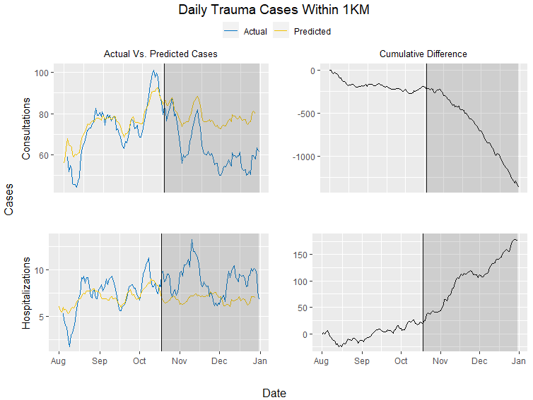

Figure 1: Seven-day moving average actual vs. predicted case plots and cumulative difference plots for daily trauma cases within 1km.

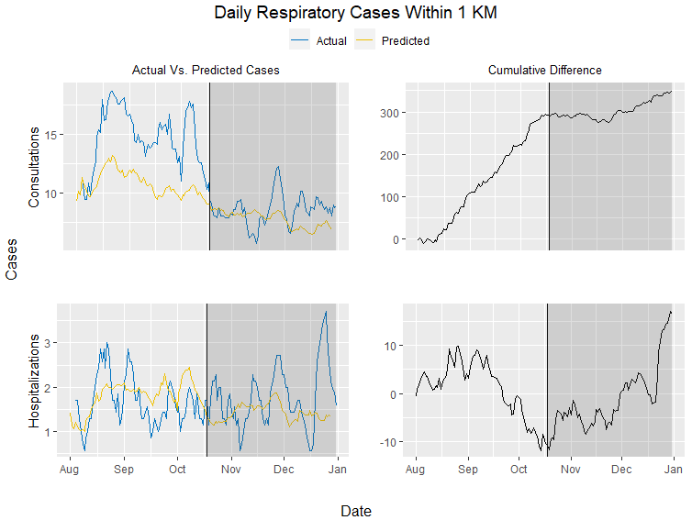

Figure 2: Seven-day moving average actual vs. predicted case plots and cumulative difference plots for daily respiratory cases within 1km.

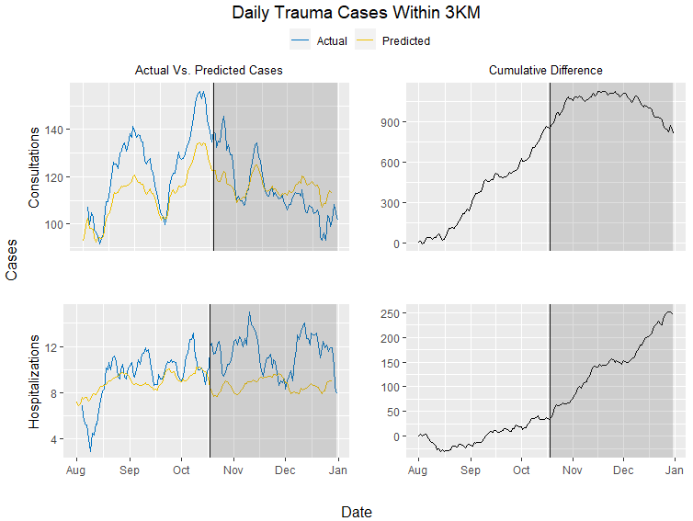

Figure 3: Seven-day moving average actual vs. predicted case plots and cumulative difference plots for daily trauma cases within 3km.

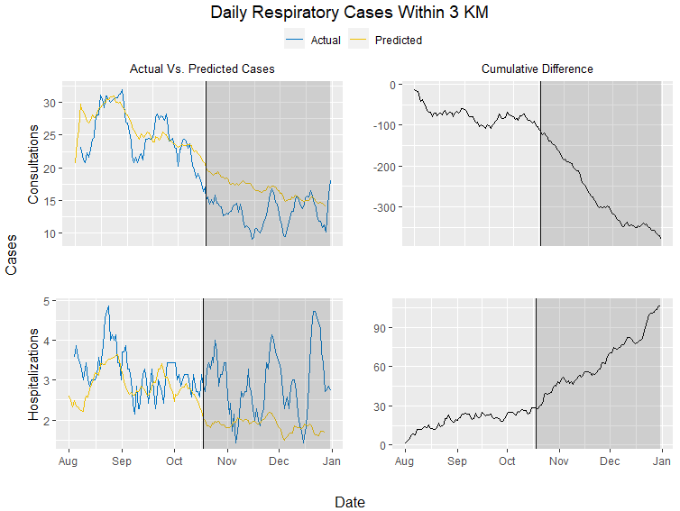

Figure 4: Seven-day moving average actual vs. predicted case plots and cumulative difference plots for daily respiratory cases within 3km.

# Discussion

Social movements resulting in civil unrests are far from being a Chilean or even a Latin American issue. Recent demonstrations have occurred for different reasons in countries such as France, Hong Kong, Syria, Colombia, Bolivia, Ecuador, and the U.S. For example, the recent killing of George Floyd in Minneapolis, Minnesota triggered unrests in the U.S. and abroad. As in Chile, most of these protests resulted in a widespread use of anti-riot shotguns and tear gas as means of crowd control. The medical and public health community have raised concerns in the indiscriminate use of these methods and the potential harm to those involved in confrontation and surrounding areas (CITE AJPH and Lancet letters/editorials).

The findings in our study suggest that following the onset of the Chilean social protests on October 18th, 2019, there was a significant reduction in patient utilization of emergency services in Santiago. The findings also suggest that there was a relative increase in the severity of cases that actually presented to emergency services.

There are a few possible ways to explain the reduction in emergency services utilization. During this protest period, individuals with non-severe or life-threatening emergencies who would normally visit emergency services may reasonably avoided these hospitals. During confrontations, most minor and mild injuries were treated in site by health professional volunteering, decompressing ER from mild or non-life-threatening problems. Also, as public transportation was significantly disrupted during the protests, prospective patients may not have even been able to make it to these hospitals to receive care.

Regarding severe ER cases requiring hospitalizations, it is likely that increases in violence during the social protests and widespread use of crowd control methods by the police resulted in a larger number of severely injured patients requiring hospitalization. However, other explanations cannot be rejected at this point. For example, these shifts may also be due to a similar reason as the reduction in emergency services utilization. Patients may be avoiding care they need to resolve minor health issues, but in turn the health issues become worse until the patient must be hospitalized with what is now a severe medical case.

*Implications*

The results of this study should be seen as a first step in better understanding the broader health effects of largescale social protests like the Chilean protests but may have several implications moving forward. First, this evidence-based research could provide health services with crucial information during times of civil unrest and support decisions to reallocate resources to places where resources are most needed to provide sufficient care. Second, this research could be used as evidence to advocate for and advise policy change regarding law enforcement responses to civil unrest to reduce the broader negative health effects of social protests.

*Limitations*

There were several limitations during the course of this study. The first and perhaps most important limitation was the difficulty in obtaining hospital data from private institutions near the focal point of the protests. Although about 80% have public health insurance and likely use the public health system, there is a fraction of the potential cases that will not be captured in our study. In addition, the degree of detail of emergency data in Chile is far from being ideal. We were only able to use the primary cause of admission; thus, contributory causes were not explored in the study. Finally, the cause of admissions were grouped in broad categories such trauma or respiratory, but not in the specific code at admission.

**Conclusions**

Taken from original introduction (could be used at the discussion)

Although the literature is far from a consensus, a social movement must have a common goal, joint action or effort against an antagonist, and some degree of organization and temporal continuity.9 These movements usually begin with an initiating event that sparks widespread discontent, such as the killing of George Floyd in Minneapolis, Minnesota in 2020 and the subway fare hike in Santiago, Chile in October 2019.10,11,2 Unorganized groups then join together into collective action to push for long-lasting change. Social movements typically end in success, failure, repression, co-optation, or establishment in the mainstream.10

During social movements, participants may intentionally cause public disturbance that violates the law - an act known as civil unrest.12 Participants can become hostile toward authority and may engage in violent or destructive actions that can have significant direct and indirect health effects on local populations.13,14,15

***Health effects of civil unrest***

Much of the current research linking social movements and health have focused on indirect effects of protest, demonstration, and civil unrest. For example, the shutdown of city streets, reductions in tourism, and disruption of public transportation can all affect the economy, which in turn can produce severe public health threats to local residents, such as food insecurity or a deterioration of hygiene condition.13,14,15 Although there is little current evidence, the onset of violence or the disruption of public transportation during periods of civil unrest may also cause restricted access to health services.

Evidence of the direct health effects of civil unrests are even more noticeable in media coverage. Crowd control methods during protests such rubber bullets have been cited to cause eye injuries, lacerations, contusions, and hematomas.16,17,18,27 Burns and physical blows from batons, bottles, bricks, boots, and other objects also account for physical injury during protests.17 Of similar consequence, the use of tear gases –a subset of riot control agents that cause tears, eye pain, and difficulty keeping the eyes open– are suggested to have the capacity to cause both short- and long-term negative health consequences on those affected.19,20,21 Short-term effects of tear gas exposure include coughing, wheezing, shortness of breath, laryngospasm, and acute respiratory arrest, with symptoms lasting upward of two weeks.20,21 Chronic bronchitis, reactive airway disease, and a variety of persistent respiratory symptoms (e.g. chest tightness, exercise dyspnea, daily phlegm) are all reported long-term effects of tear gas exposure. Other respiratory problems may arise from hazardous material exposure as a result of the burning and destruction of buildings and reductions in air quality in general, all of which may have significant public health implications.15

Despite what is known about the direct and indirect health effects of civil unrest, there is limited research regarding the effects of social protests on patient utilization of health system services, and most of what is known comes from non-scientific reports and media coverage.20,22

***The Chilean protests of 2019***

The Chilean protests of October 2019 were rooted in historical injustices and calls to equality. The current constitution was drafted under the Pinochet regime in 1980 without many of the human rights securities that protestors demand. Since this time, and especially after the return to democracy, there has been a rapid economic growth and an improvement of many social and health indicators (e.g. poverty, infant mortality, life expectancy). However, the country’s current economic model has reproduced many of the historical social inequities.2 The richest 1% of the Chilean population earns 33% of the nation’s wealth, while about 50% of Chilean workers make less than 400,000 pesos per month, roughly $550 USD.2,24,25

The protests were initially spurred by a metro fare increase of 30 pesos (about $0.04 USD), but the demonstrations quickly began to encompass the anger stemming from economic inequality and insufficient social services. Protestors called for structural changes related to social inequalities, rising costs of living, stagnant wages, and gender violence, as well as a new constitution.1 Demonstrations included the looting of supermarkets and the torching of 22 metro stations within the first week.2 The protests featured high attendance rates (more than 1.2 million people in Santiago alone) and strong national support, with 55% of Chileans supporting the continuation of the protests. Within days, the government declared a state of emergency and deploying the Chilean police, Carabineros, who utilized anti-riot shotguns and tear gas as a means of crowd control

# References

1. Vergara L. Why social movements matter for addressing inequalities and ensuring social justice. In: UNESCO/ISSC. World social science report, 2016: Challenging inequalities, pathways to a just world. Paris, France, 2016. Pages 250-53.
2. Berger S & Nehring H. Introduction: Towards a Global History of Social Movements. In: S. Berger, H. Nehring (eds.). The History of Social Movements in Global Perspective. Palgrave Macmillan UK, 2017. Pages 1-35.
3. . Scott J, Marshall G. A Dictionary of Sociology. 3rd ed. Oxford University Press; 2009. doi:10.1093/acref/9780199533008.001.0001
4. Opp K-D. Theories of Political Protest and Social Movements: A Multidisciplinary Introduction, Critique, and Synthesis. Routledge; 2009.
5. Diani M. The Concept of Social Movement. Sociol Rev. 1992;40(1):1-25. Doi:10.1111/j.1467-954X.1992.tb02943.x
6. https://www.nfpa.org/-/media/Files/News-and-Research/Resources/Fire-service/Responder-Forum/2015-NFPA-responders-forum-Civil-Unrest-Paper.ashx?la=en
7. Krygier R. Chile is preparing to rewrite its constitution. Why are people still protesting? Washington Post. https://www.washingtonpost.com/world/the_americas/chile-is-preparing-to-rewrite-its-constitution-why-are-people-still-protesting/2020/02/01/eb7ee6b2-43cc-11ea-99c7-1dfd4241a2fe_story.html. Accessed August 11, 2020.
8. Johanson M. How a 4-cent metro fare price hike sparked massive unrest in Chile. Vox. Published October 29, 2019. Accessed August 9, 2020. <https://www.vox.com/world/2019/10/29/20938402/santiago-chile-protests-2019-riots-metro-fare-pinera>
9. von Elm E, Madrid E, Urrutia G. Chile: civil unrest and Cochrane Colloquium cancelled. Lancet . 2019 Nov 9;394(10210):e35.
10. emol. [La cronología de los hechos que detonaron la crisis social y los días de estado de emergencia en el país]. Avaible on: https://www.emol.com/noticias/Nacional/2019/10/23/965179/Cronologia-Crisis-Social-Evasion-Protestas.html
11. Yimgang DP, Wang Y, Paik G, Hager ER, Black MM. ivil Unrest in the Context of Chronic Community Violence: Impact on Maternal Depressive Symptoms. Am J Public Health . 2017 Sep;107(9):1455-1462
12. Dangmann CR, Solberg Ø, Steffenak AKM, Høye S, Andersen PN. Health-related quality of life in young Syrian refugees recently resettled in Norway. Scand J Public Health . 2020 Jul 2;1403494820929833
13. Evans CA Jr. Public health impact of the 1992 Los Angeles civil unrest. Public Health Rep . May-Jun 1993;108(3):265-72.
14. Robertson E. Venezuelan unrest increases pressure on health services. Lancet . 2014 Mar 15;383(9921):942.
15. The Lancet Oncology. Hong Kong: long civil unrest with long-term consequences. Lancet Oncol . 2020 Jan;21(1):1.
16. . Rust G et al. Practical barriers to timely primary care access: impact on adult use of emergency department services. Arch Intern Med . 2008 Aug 11;168(15):1705-10
17. Jones AP, Bentham G, Horwell C. Health service accessibility and deaths from asthma. Int J Epidemiol . 1999 Feb;28(1):101-5.
18. Nicholl J, West J, Goodacre S, Turner J. The relationship between distance to hospital and patient mortality in emergencies: an observational study. Emerg Med J . 2007 Sep;24(9):665-8.
19. Ballantyne B. Medical management of the traumatic consequences of civil unrest incidents: causation, clinical approaches, needs and advanced planning criteria. Toxicol Rev . 2006;25(3):155-97.
20. Rodríguez Á, Peña S, Cavieres I, et al. Ocular trauma by kinetic impact projectiles during civil unrest in Chile [published online ahead of print, 2020 Aug 24]. *Eye (Lond)*. 2020;1-7. doi:10.1038/s41433-020-01146-w
21. Blain PG. Tear Gases and Irritant Incapacitants: 1-Chloroacetophenone, 2-Chlorobenzylidene Malononitrile and Dibenz[B,F]-1,4-Oxazepine. Toxicol Rev. 2003;22(2):103-110. doi:10.2165/00139709-200322020-00005
22. Arbak P, Başer İ, Kumbasar ÖO, Ülger F, Kılıçaslan Z, Evyapan F. Long Term Effects of Tear Gases on Respiratory System: Analysis of 93 Cases. The Scientific World Journal. doi:https://doi.org/10.1155/2014/963638
23. Uslu E, Ozkan G, Kucuk CU, et al. Respiratory effects of tear gas inhalation. Eur Respir J. 2014;44(Suppl 58). Accessed August 13, 2020. https://erj.ersjournals.com/content/44/Suppl_58/P4958

# OLD REFERENCE LIST

1. Krygier R. Chile is preparing to rewrite its constitution. Why are people still protesting? *Washington Post*. https://www.washingtonpost.com/world/the_americas/chile-is-preparing-to-rewrite-its-constitution-why-are-people-still-protesting/2020/02/01/eb7ee6b2-43cc-11ea-99c7-1dfd4241a2fe_story.html. Accessed August 11, 2020.

2. Johanson M. How a 4-cent metro fare price hike sparked massive unrest in Chile. Vox. Published October 29, 2019. Accessed August 9, 2020. https://www.vox.com/world/2019/10/29/20938402/santiago-chile-protests-2019-riots-metro-fare-pinera

3. World Report 2020: Rights Trends in Chile. Human Rights Watch. Published December 6, 2019. Accessed August 11, 2020. https://www.hrw.org/world-report/2020/country-chapters/chile

4. Departamento de Estadisticas e Información de Salud. Accessed August 13, 2020. https://deis.minsal.cl/

5. Hine DC, Morris AD. The Origins of the Civil Rights Movement: Black Communities Organizing for Change. *J South Hist*. 1985;51(4):652. doi:10.2307/2209556

6. Campante FR, Chor D. Why Was the Arab World Poised for Revolution? Schooling, Economic Opportunities, and the Arab Spring. *J Econ Perspect*. 2012;26(2):167-188. doi:10.1257/jep.26.2.167

7. Scott J, Marshall G. *A Dictionary of Sociology*. 3rd ed. Oxford University Press; 2009. doi:10.1093/acref/9780199533008.001.0001

8. Opp K-D. *Theories of Political Protest and Social Movements: A Multidisciplinary Introduction, Critique, and Synthesis*. Routledge; 2009.

9. Diani M. The Concept of Social Movement. *Sociol Rev*. 1992;40(1):1-25. doi:10.1111/j.1467-954X.1992.tb02943.x

10. Four Stages of Social Movements. Accessed August 9, 2020. https://www.ebscohost.com/uploads/imported/thisTopic-dbTopic-1248.pdf

11. George Floyd, From ‘I Want to Touch the World’ to ‘I Can’t Breathe’ - The New York Times. Accessed August 9, 2020. https://www.nytimes.com/article/george-floyd-who-is.html

12. 2015-NFPA-responders-forum-Civil-Unrest-Paper.pdf. Accessed August 9, 2020. https://www.nfpa.org/-/media/Files/News-and-Research/Resources/Fire-service/Responder-Forum/2015-NFPA-responders-forum-Civil-Unrest-Paper.ashx?la=en

13. Unrest is costing Chile’s economy, but protesters press on. Accessed August 9, 2020. <https://www.aljazeera.com/ajimpact/unrest-costing-chiles-economy-protesters-press-191210194124885.html>

14. Chile announces $5.5 billion economic recovery plan as protests bite - Reuters. Accessed August 9, 2020. <https://www.reuters.com/article/us-chile-economy-imacec/chile-announces-5-5-billion-economic-recovery-plan-as-protests-bite-idUSKBN1Y6173>

15. Evans CA. Public health impact of the 1992 Los Angeles civil unrest. *Public Health Rep*. 1993;108(3):265-272.

16. Balouris CA. Rubber and plastic bullet eye injuries in Palestine. *The Lancet*. 1990;335(8686):415. doi:10.1016/0140-6736(90)90252-Z

17. The injuries and management of riot casualties admitted to the belfast hospital wards, August to October, 1969 - Robb - 1971 - BJS (British Journal of Surgery) - Wiley Online Library. Accessed August 13, 2020. <https://bjssjournals.onlinelibrary.wiley.com/doi/pdf/10.1002/bjs.1800580604?casa_token=Xlr6xVzi_hUAAAAA%3AwLn8C9fRQtz3gFXx7a7jhbuUJ5UyLCBRSCyj0UG4Kq4aen5HtNA5H6lLcDu-rA7wFNpGYuHrFXd7ecC7>

18. Sheridan S, Whitlock, Roy, I.H. Plastic Baton Round Injuries. *British Journal of Oral Surgery*. 1983;21: 259-267.

19. Blain PG. Tear Gases and Irritant Incapacitants: 1-Chloroacetophenone, 2-Chlorobenzylidene Malononitrile and Dibenz[B,F]-1,4-Oxazepine. *Toxicol Rev*. 2003;22(2):103-110. doi:10.2165/00139709-200322020-00005

20. Arbak P, Başer İ, Kumbasar ÖO, Ülger F, Kılıçaslan Z, Evyapan F. Long Term Effects of Tear Gases on Respiratory System: Analysis of 93 Cases. The Scientific World Journal. doi:https://doi.org/10.1155/2014/963638

21. Uslu E, Ozkan G, Kucuk CU, et al. Respiratory effects of tear gas inhalation. *Eur Respir J*. 2014;44(Suppl 58). Accessed August 13, 2020. https://erj.ersjournals.com/content/44/Suppl_58/P4958

22. Hu H, Christiani D. Reactive airways dysfunction after exposure to teargas. *The Lancet*. 1992;339(8808):1535. doi:10.1016/0140-6736(92)91296-K

23. What lies behind the protests in Venezuela? *BBC News*. https://www.bbc.com/news/world-latin-america-26335287. Published March 27, 2014. Accessed August 11, 2020.

24. Palet A, Aguirre P de, PNUD Chile, eds. *Desiguales: Orígenes, Cambios y Desafíos de La Brecha Social En Chile*. PNUD : Uqbar Editores; 2017.

25. Los-Verdaderos-Salarios-ESI-2018-1.pdf. Accessed August 11, 2020. <http://www.fundacionsol.cl/wp-content/uploads/2019/08/Los-Verdaderos-Salarios-ESI-2018-1.pdf>

26. Informe de resultados oficial Encuesta Zona Cero. *Núcleo de Sociología Contingente.* 2020. <https://doi.org/10.31219/osf.io/76mdz>. Accessed September 8, 2020.

27. Rodríguez Á, Peña S, Cavieres I, et al. Ocular trauma by kinetic impact projectiles during civil unrest in Chile [published online ahead of print, 2020 Aug 24]. *Eye (Lond)*. 2020;1-7. doi:10.1038/s41433-020-01146-w

Table 1.

Figure 1. Estimated Trends of the Outcomes of Interest



Figure 2. Estimated Pointwise Trends of the Outcomes of Interest (zoom into social protests)



Figure 3. Estimated Cumulative Differences Between Actual and Estimated Trends in the Outcomes of Interest (zoom into social protests)

